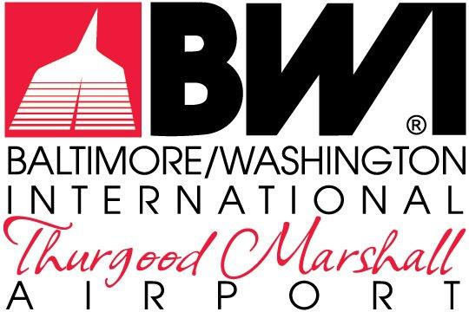

ATTACHMENTS

REQUEST FOR PROPOSALS
MDOT-AC-2023

September 2023

FOR THE NON-EXCLUSIVE RIGHT TO REDEVELOP,
RENOVATE, LEASE & MANAGE THE RETAIL, RESTAURANT &
COMMERCIAL SERVICES
AT
BALTIMORE/WASHINGTON INTERNATIONAL
THURGOOD MARSHALL AIRPORT

The Maryland Aviation Administration is a modal unit of
the Maryland Department of Transportation.

MARYLAND DEPARTMENT OF TRANSPORTATION
MARYLAND AVIATION ADMINISTRATION

REQUEST FOR PROPOSALS NO. MDOT-AC-2023

FOR THE NON-EXCLUSIVE RIGHT TO REDEVELOP,
RENOVATE, LEASE & MANAGE THE RETAIL, RESTAURANT &
COMMERCIAL SERVICES
AT
BALTIMORE/WASHINGTON INTERNATIONAL
THURGOOD MARSHALL AIRPORT

List of Attachments

Attachment No. 1 Lease and/or Concessions Contracts General Provisions
Attachment No. 2 Tenant Directive 003.1 – Trash Disposal and Recycling at BWI Marshall Airport
Attachment No. 3 Tenant Directive 401.1 – Standard Rates and Fees at BWI Marshall
Attachment No. 4 Tenant Directive 502.1 – Airport Fuel/Oil and Hazardous Material Spill Procedures and Legal Reporting Responsibilities
Attachment No. 5 Maryland Aviation Administration’s Permit Information Guide, dated 2021
Attachment No. 6 Airport Tenant Guide For Trash and Cardboard Disposal
Attachment No. 7 Maryland Transportation Code Annotated Section 5-408

