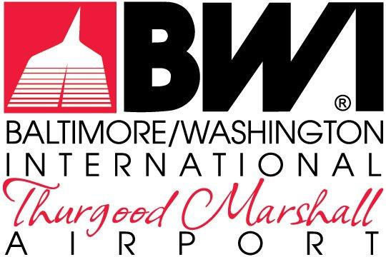

ATTACHMENTS

LEASE AND CONCESSION CONTRACT
MDOT-AC-2023A

September 2023

FOR THE NON-EXCLUSIVE RIGHT TO REDEVELOP,
RENOVATE, LEASE & MANAGE THE RETAIL, RESTAURANT &
COMMERCIAL SERVICES
AT
BALTIMORE/WASHINGTON INTERNATIONAL
THURGOOD MARSHALL AIRPORT

The Maryland Aviation Administration is a modal unit of
the Maryland Department of Transportation.

MARYLAND DEPARTMENT OF TRANSPORTATION
MARYLAND AVIATION ADMINISTRATION

LEASE AND CONCESSION CONTRACT
MDOT-AC-2023A

FOR THE NON-EXCLUSIVE RIGHT TO REDEVELOP,
RENOVATE, LEASE & MANAGE THE RETAIL, RESTAURANT &
COMMERCIAL SERVICES
AT
BALTIMORE/WASHINGTON INTERNATIONAL
THURGOOD MARSHALL AIRPORT

List of Attachments

- Lease and/or Concession Contracts General Provisions for BWI Marshall Airport
- Tenant Directive 003.1 – Trash Disposal and Recycling at BWI Marshall International Airport
- Tenant Directive 401.1 - Standard Rates and Fees at Baltimore/Washington Thurgood Marshall International Airport
- Tenant Directive 502.1 – Airport Fuel/Oil and Hazardous Material Spill Procedures and Legal Reporting Responsibilities
- Maryland Aviation Administration’s Permit Information Guide
- Tenant Guide for Trash and Cardboard Disposal at BWI Marshall Airport
- Tenant Directive BWI 500.2 – Green Concessions
- Food Waste Composting Program
- Maryland Public Ethics Law Affidavit
- Nondiscrimination Provisions
- Tenant Design Standards
  - Information Package for Contractors & Construction
  - Tenant Design Standard for Retail and Commercial Services Tenants
  - Tenant Design Standard for Restaurant & Food Court Tenants
- Sublease Form

