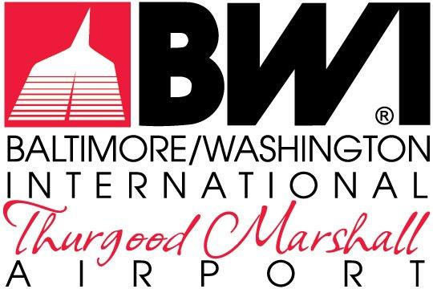

EXHIBITS

LEASE AND CONCESSION CONTRACT
MDOT-AC-2023A

September 2023

FOR THE NON-EXCLUSIVE RIGHT TO REDEVELOP,
RENOVATE, LEASE & MANAGE THE RETAIL, RESTAURANT &
COMMERCIAL SERVICES
AT
BALTIMORE/WASHINGTON INTERNATIONAL
THURGOOD MARSHALL AIRPORT

The Maryland Aviation Administration is a modal unit of
the Maryland Department of Transportation.

MARYLAND DEPARTMENT OF TRANSPORTATION
MARYLAND AVIATION ADMINISTRATION

LEASE AND CONCESSION CONTRACT
MDOT-AC-2023A

FOR THE NON-EXCLUSIVE RIGHT TO REDEVELOP,
RENOVATE, LEASE & MANAGE THE RETAIL, RESTAURANT &
COMMERCIAL SERVICES
AT
BALTIMORE/WASHINGTON INTERNATIONAL
THURGOOD MARSHALL AIRPORT

List of Exhibits

Exhibit A - Request For Proposal No. MDOT-AC-2023 and all subsequently issued addenda
Exhibit B - Contract Affidavit, executed by the Lessee
Exhibit C - Lessee's Proposal (including Best and Final Offer (BAFO) if applicable)
Exhibit D - Lessee’s Assigned Office Space
Exhibit E - Leased Premises: Concession Area, Concession Storage
Exhibit F - Direct Recognition Agreement
Exhibit G - Concession Maintenance Responsibility Matrix
Exhibit H - Administration’s Concession Design Criteria
Exhibit I - Delivery & Distribution Zones
Exhibit J - Concessions Support & Storage Spaces
Exhibit K - Logistics Provider Sample Contract

