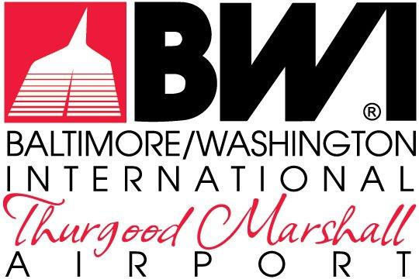

ATTACHMENTS

LOGISTICS PROVIDER LEASE
MDOT-AC-2023B

FOR THE EXCLUSIVE RIGHT TO OPERATE AND MANAGE AN
INTEGRATED LOGISTICS SERVICE AND
CENTRALIZED RECEIVING & DISTRIBUTION CENTER
AT
BALTIMORE/WASHINGTON INTERNATIONAL
THURGOOD MARSHALL AIRPORT

The Maryland Aviation Administration is a modal unit of
the Maryland Department of Transportation.

MARYLAND DEPARTMENT OF TRANSPORTATION
MARYLAND AVIATION ADMINISTRATION

LOGISTICS PROVIDER LEASE
MDOT-AC-2023B

FOR THE EXCLUSIVE RIGHT TO OPERATE AND MANAGE AN
INTEGRATED LOGISTICS SERVICE AND
CENTRALIZED RECEIVING & DISTRIBUTION CENTER
AT
BALTIMORE/WASHINGTON INTERNATIONAL
THURGOOD MARSHALL AIRPORT

List of Attachments

Attachment No. 1 Permit Information Guide
Attachment No. 2 Tenant Directive 003.1 – Trash Disposal & Recycling
Attachment No. 3 Airport Community Tenant Guide for Trash and Cardboard Disposal
Attachment No. 4 Tenant Guide for Food Waste Disposal
Attachment No. 5 Tenant Directives Regarding Airfield Operations Area (AOA)
Attachment No. 6 Non-Discrimination Provisions
Attachment No. 7 Maryland Public Ethics Affidavit
Attachment No. 8 Lease and/or Concession Contracts General Provisions
for BWI Marshall Airport, dated May 2019
Attachment No. 9 Contract Affidavit

