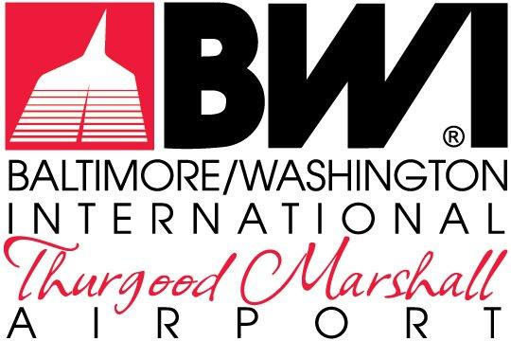

EXHIBITS

LOGISTICS PROVIDER LEASE
MDOT-AC-2023B

FOR THE EXCLUSIVE RIGHT TO OPERATE AND MANAGE AN
INTEGRATED LOGISTICS SERVICE AND
CENTRALIZED RECEIVING & DISTRIBUTION CENTER
AT
BALTIMORE/WASHINGTON INTERNATIONAL
THURGOOD MARSHALL AIRPORT

The Maryland Aviation Administration is a modal unit of
the Maryland Department of Transportation.

MARYLAND DEPARTMENT OF TRANSPORTATION
MARYLAND AVIATION ADMINISTRATION

LOGISTICS PROVIDER LEASE
MDOT-AC-2023B

FOR THE EXCLUSIVE RIGHT TO OPERATE AND MANAGE AN
INTEGRATED LOGISTICS SERVICE AND
CENTRALIZED RECEIVING & DISTRIBUTION CENTER
AT
BALTIMORE/WASHINGTON INTERNATIONAL
THURGOOD MARSHALL AIRPORT

List of Exhibits

Exhibit A Leased Premises
Exhibit B Delivery and Distribution Zones

