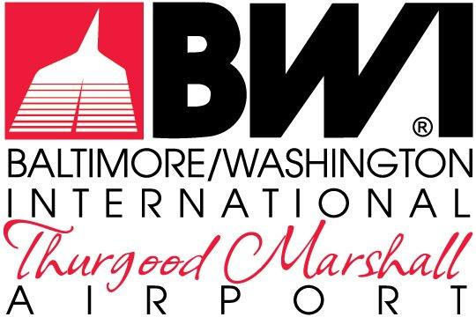

EXHIBITS

REQUEST FOR PROPOSALS
MDOT-AC-2023

September 2023

FOR THE NON-EXCLUSIVE RIGHT TO REDEVELOP,
RENOVATE, LEASE & MANAGE THE RETAIL, RESTAURANT &
COMMERCIAL SERVICES
AT
BALTIMORE/WASHINGTON INTERNATIONAL
THURGOOD MARSHALL AIRPORT

The Maryland Aviation Administration is a modal unit of
the Maryland Department of Transportation.

MARYLAND DEPARTMENT OF TRANSPORTATION
MARYLAND AVIATION ADMINISTRATION

REQUEST FOR PROPOSALS NO. MDOT-AC-2023

FOR THE NON-EXCLUSIVE RIGHT TO REDEVELOP,
RENOVATE, LEASE & MANAGE THE RETAIL, RESTAURANT &
COMMERCIAL SERVICES
AT
BALTIMORE/WASHINGTON INTERNATIONAL
THURGOOD MARSHALL AIRPORT

List of Exhibits

Exhibit A Sample Developer Lease & Concession Contract
Exhibit B Concession Developer Office Space
Exhibit C Concession Operational and Storage Area
Exhibit D Direct Recognition Agreement
Exhibit E Concessions Maintenance Responibility Matrix
Exhibit F Concessions Design Criteria – Supplemental Architectural Document
Exhibit G Sample Logistics Provider Lease
Exhibit H Concession Program Support and Storage Space
Exhibit I Terminal Delivery Zones and Paths
Exhibit J Concessions Space-Unit Roster

