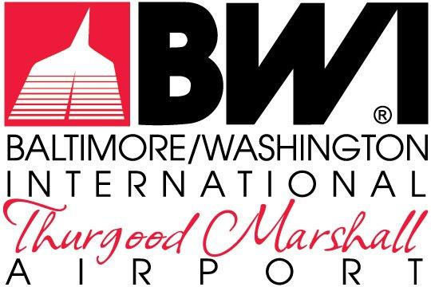

FORMS

REQUEST FOR PROPOSALS
MDOT-AC-2023

September 2023

FOR THE NON-EXCLUSIVE RIGHT TO REDEVELOP,
RENOVATE, LEASE & MANAGE THE RETAIL, RESTAURANT &
COMMERCIAL SERVICES
AT
BALTIMORE/WASHINGTON INTERNATIONAL
THURGOOD MARSHALL AIRPORT

The Maryland Aviation Administration is a modal unit of
the Maryland Department of Transportation.

MARYLAND DEPARTMENT OF TRANSPORTATION
MARYLAND AVIATION ADMINISTRATION

REQUEST FOR PROPOSALS NO. MDOT-AC-2023

FOR THE NON-EXCLUSIVE RIGHT TO REDEVELOP,
RENOVATE, LEASE & MANAGE THE RETAIL, RESTAURANT &
COMMERCIAL SERVICES
AT
BALTIMORE/WASHINGTON INTERNATIONAL
THURGOOD MARSHALL AIRPORT

List of Forms

Form No. 1 Proposer Registration Form
Form No. 2 Pre-Proposal Conference Accommodation Request Form
Form No. 3 Airport Tour Registration Form
Form No. 4 Exceptions Form
Form No. 5 Proponent/Contractor Solicitation Comment Form
Form No. 6 Acknowledgement of Receipt Form
Form No. 7 Bid/Proposal Affidavit
Form No. 8 Solicitation Affirmation Form
Form No. 9 Commitment Statement
Form No. 10 Maryland Public Ethics Law Affidavit
Form No. 11 Sample Guaranty of Performance
Form No. 12 Non-Collusion Statement
Form No. 13 Financial Proposal Form
Form No. 14 Proposal Submittal Checklist
Form No. 15 Contract Affidavit
Form No. 16 Financial Pro Forma Statement
Form No. 17 Corporate Diversity Form

