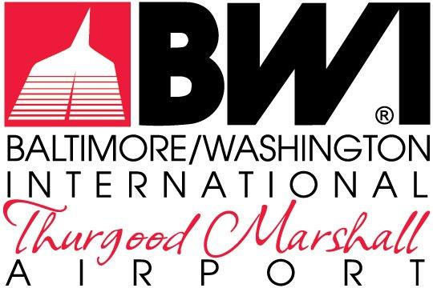

GENERAL INFORMATION

REQUEST FOR PROPOSALS
MDOT-AC-2023

September 2023

FOR THE NON-EXCLUSIVE RIGHT TO REDEVELOP,
RENOVATE, LEASE & MANAGE THE RETAIL, RESTAURANT &
COMMERCIAL SERVICES
AT
BALTIMORE/WASHINGTON INTERNATIONAL
THURGOOD MARSHALL AIRPORT

The Maryland Aviation Administration is a modal unit of
the Maryland Department of Transportation.

MARYLAND DEPARTMENT OF TRANSPORTATION
MARYLAND AVIATION ADMINISTRATION

REQUEST FOR PROPOSALS NO. MDOT-AC-2023

FOR THE NON-EXCLUSIVE RIGHT TO REDEVELOP,
RENOVATE, LEASE & MANAGE THE RETAIL, RESTAURANT &
COMMERCIAL SERVICES
AT
BALTIMORE/WASHINGTON INTERNATIONAL
THURGOOD MARSHALL AIRPORT

List of General Information

Gen. Info. No. 1 Sublease Expiry Report
Gen. Info. No. 2 Operational Management & Performance
Gen. Info. No. 3 Opportunity Performance & Analysis
Gen. Info. No. 4 Air Service & Passenger Performance
Gen. Info. No. 5 Concessions Analysis & Performance
Gen. Info. No. 6 Demographic & Psychographic Analysis
Gen. Info. No. 7 MEP Capacity Study
Gen. Info. No. 8 SmartCity Wireless’ Menu of Services
Gen. Info. No. 9 2019 BWI Marshall Concessions Program Wage and Benefits Report
Gen. Info. No. 10 BWI Marshall Airport Advertising Master Plan
Gen. Info. No. 11 Draft BWI Marshall Master Plan Forecast Summary of Passengers and Operations
Gen. Info. No. 12 Airports Council International’s Air Service Quality Survey 2023
Gen. Info. No. 13 Airports Council International’s Air Survive Quality Benchmark Survey 2023
Gen. Info. No. 14 BWI Passenger Survey 2023
Gen. Info. No. 15 Concession Hours of Operation
Gen. Info. No. 16 Food Court Seating and Layout
Gen. Info. No. 17 Airline Gate Utilization and Assignment
Gen. Info. No. 18 Rent Roll
Gen. Info. No. 19 Air Service Passenger Data
Gen. Info. No. 20 COMAR 11.03.01.05
Gen. Info. No. 21 Employee Parking Program Procedural Manual
Gen. Info. No. 22 COMAR 11.03.01.06

