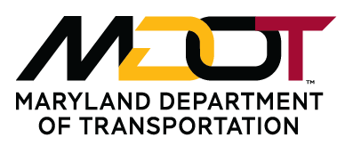 MDOT Reinstatement Request Form

Last 4 Digits of
Name: Social Security #:
(This will be used to verify your employment)

Address: Home Phone:
(Number and Street)

Address: ____________________________________________________________________________________
(City, State, Zip)

Email Address:

Previous Transportation Business Unit(s) Please circle: MAA MVA MDTA MPA TSO MTA SHA

What was your former classification?

Lower levels of the same job class you would like to be on the list for:
(Example: if you were a Transportation Engineer III, you can also ask to be on the list for level I and II)

IF YOU ANSWER “Yes” TO ANY OF THE QUESTIONS BELOW, YOU ARE NOT ELIGIBLE TO BE PLACED ON MDOT’S REINSTATEMENT LIST. PLEASE DO NOT SUBMIT THIS FORM.

- Did you leave Transportation Services more then 5 years ago? Yes No

- Were you a Temporary (TE), Contractual, Consultant or Temporary Agency employee when you worked for Transportation Services? Yes No

- Were you a Union (hourly wage) employee (including MTA and MdTA police officers)? Yes No
Union employees (including Police Officers) should contact their former Administration/Authority for information on reinstatement.

- Were you disqualified from future employment at all MDOT Agencies? Yes No

- Are you currently a Career Service (permanent), Executive Service or Commission Plan employee at any of the following Transportation Business Units: MAA, MdTA, MPA, MTA, MVA, SHA or TSO? Yes No

- Are you a current or former State employee who HAS NOT worked for an MDOT Transportation Business Unit or Authority within the past 5 years? Yes No

Having your name placed on the reinstatement list will not guarantee you will get your former job back or be re-hired by any MDOT Administration. NOTE: There are specific reinstatement rights that apply to employees returning from Active Duty military service. Employees/former employees returning from Active Duty military service or who are hospitalized and/or recuperating after discharge should contact their former MDOT Transportation Business Unit’s Employment & Benefits Office, in Human Resources, as soon as possible for more information on their reinstatement rights. Time limits may apply.

Signature: Date:
Submit form to: MDOT Recruitment and Exams Fax: 410-865-1301
7201 Corporate Center Drive Phone: 410-865-1073
Mail Stop 140
Hanover, MD 21076

